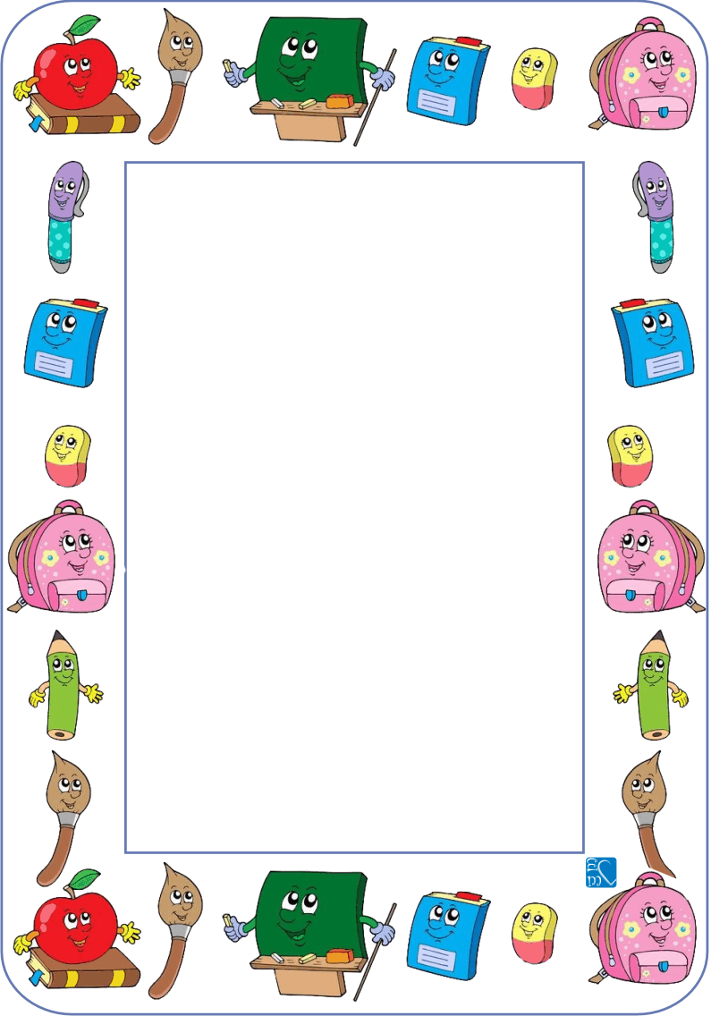

**Kindergarten**

**Things I need for School:**

* 2 plastic envelope folders (“Polly-Wallies”) labelled with your child’s name
* 8 large glue sticks (Bostik brand please)
* 8 whiteboard markers (black or blue)
* A paint shirt labelled with child’s name

(An old adult shirt will do)

* A library bag labelled with your child’s name
* 2 boxes of tissues
* 2 packets of baby wipes
* Headphones
* **No pencils or textas are required**

Thank you!